Version 1.0 – January 16, 2017 – Stephen Downes

Executive Summary

Introduction

The research project with CSPS focuses on five key areas: a) learning through mobile, b) personalized learning, c) shared learning space (crowd-sourcing), d) virtual library, and e) integration with the Government of Canada social and collaboration platforms.

Learning Through Mobile

Current State of the Art

What is Mobile Learning?
Mobile learning is most commonly defined with reference to the devices employed. (Ally, 2008, JISC 2011) For example, ISO describes it as “the use of mobile devices to support learning.” (ISO+ITC+TS 29140) This definition however may be broadened to include multiple contexts:

- The mobility of the device - includes learning enabled with mobile phones, tablets, laptops, and today can include augmented learning and devices such as smart glasses

- The mobility of the learner - includes the “embeddedness of the learner in the real environment or in context”

- The mobility of the information - includes the concepts of just-in-time learning and performance support

We can also think of mobile learning operationally, or in terms of its affordances. (Berking & Haag, 2015) Some of the more important affordances of mobile learning include “the opportunity to overcome physical constraints by having access to people and digital learning resources, regardless of place and time" (Kukulska-Hulme, 2010) and the processes (both personal and public) of coming to know through exploration and conversation across multiple contexts amongst people and interactive technologies" (Sharples, M. et al, 2007)

Hence we may wish to consider Traxler’s conception of mobile learning, which looks beyond the mobility to address the affordances that are made possible by mobility, focusing on “user associations including such words as ‘personal,’ ‘spontaneous,’ ‘opportunistic,’ ‘informal,’ ‘pervasive,’ ‘situated,’ ‘private,’ ‘context-aware,’ ‘bite-sized,’ and ‘portable.’ This is contrasted with words from the literature of conventional e-Learning such as ‘structured,’ ‘media-rich,’ ‘broadband,’ ‘interactive,’ ‘intelligent,’ and ‘usable.’.” (Traxler, 2007)

Benefits of Mobile learning - UNESCO
- expand the reach and equity of education
- facilitate personalized learning
- provide immediate feedback and assessment
- enable anytime, anywhere learning
- ensure the productive use of time spent in classrooms
- build new communities of learners
- Support situated learning
- Enhance seamless learning
- Bridge formal and informal learning
- Minimize educational disruption in conflict and disaster areas
- Assist learners with disabilities
- Improve communication and administration
- Maximize cost-efficiency

Adoption of Mobile Learning
Mobile learning is becoming widely adopted. Even as of 2014, 30% of all smartphone owners used their device to access mobile learning (Pew, 2015). As of 2012, 74% of learners used mobile devices for eLearning. (Ambient, 2013)

An EDUCAUSE survey reports that most students use mobile devices for learning, with the percentage of smartphones increasing and the percentage of eBooks decreasing. “Percentages increased considerably among smartphone owners (from 58 to 77 percent), while among tablet and e-book owners, their use for learning decreased slightly (from 82 to 79 percent and 64 to 59 percent, respectively).” (EDUCAUSE, 2015)

The Brandon Hall Group reports “mobile learning is one of the top three learning priorities for companies in the coming year, ranking only behind the need for business alignment and stronger analytics.” However, many companies are only at early stages of mobile-readiness.

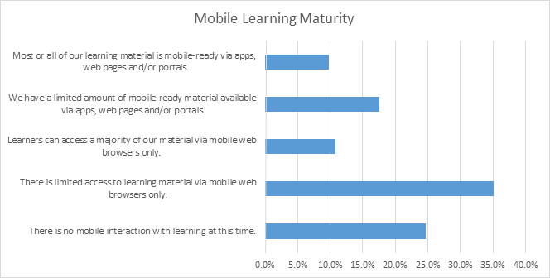
(Brandon Hall, 2015)

It should be noted that the adoption of mobile learning varies according to a number of factors. Empirical studies of technology acceptance show that major factors include ease of use, perceptions of usefulness, and attitudes toward mobile learning generally. These in turn are based on self-efficacy, relevance of the learning, system accessibility and social norms. (Park, Nam and Cha, 2011)

Mobile Learning Policy Framework
The adoption of mobile learning in an institutional context is typically accompanied by a mobile learning policy specifying such things as what devices will be supported, what level of training and service to provide, and elements of acceptable use.

The GSMA Mobile Learning Policy Handbook (2014), for example, raises the following sets of issues to be considered by a mobile learning policy:

- How is mobile learning defined and what are the rationales for supporting mobile learning in the workplace?

- What is the roadmap for deployment, and how will the stages of deployment be evaluated?

- Will the entire solution be developed in-house or will partnerships be entertained? How will the cost of supporting mobile learning be sustained?

- Is effective network access in place? Is there support for safe, secure and private access to mobile learning?

- What devices will be supported and what level of professional development related to mobile learning will be supported?

- Will mobile-specific pedagogy be employed, will mobile be used to increase learning opportunities, and what provisions will be undertaken to support special needs?

- How will learning resources be acquired, how will learning be assessed, and how will the mobile learning system be administered?

Policy Guidelines for Mobile Learning - UNESCO
- Create or update policies related to mobile learning
- Train teachers to advance learning through mobile technologies
- Provide support and training to teachers through mobile technologies
- Create and optimize educational content for use on mobile devices
- Ensure gender equality for mobile students
- Expand and improve connectivity options while ensuring equity
- Develop strategies to provide equal access for all
- Promote the safe, responsible and healthy use of mobile technologies
- Use mobile technology to improve communication and education management
- Raise awareness of mobile learning through advocacy, leadership and dialogue

Mobile learning policies can vary widely from one institution to the next; clearly, a policy developed for a K-12 school environment will not be appropriate for a professional workplace setting. Additionally, mobile policies will vary according to the extent and nature of resources and support available. Mobile learning policies should be developed through a consultative process involving major stakeholders (providers, teachers, learners, employers).

Mobile Development and Delivery Standards
The delivery of mobile learning is supported through two major sets of wireless communication standards:

- The IEEE 802.11 set of standards, commonly known as wifi, and

- CDMA (Code Division Multiple Access) and GSM (Global System for Mobiles), commonly known as he 3G, 4G and LTE sets of standards

Many mobile devices support both sets of standards, however when possible devices will default to the best possible wifi standard, because bandwidth tends to be much greater (though this can vary widely in the field) and because data charges are much lower (and in many cases, mobile data charges are borne personally by the mobile device owner).

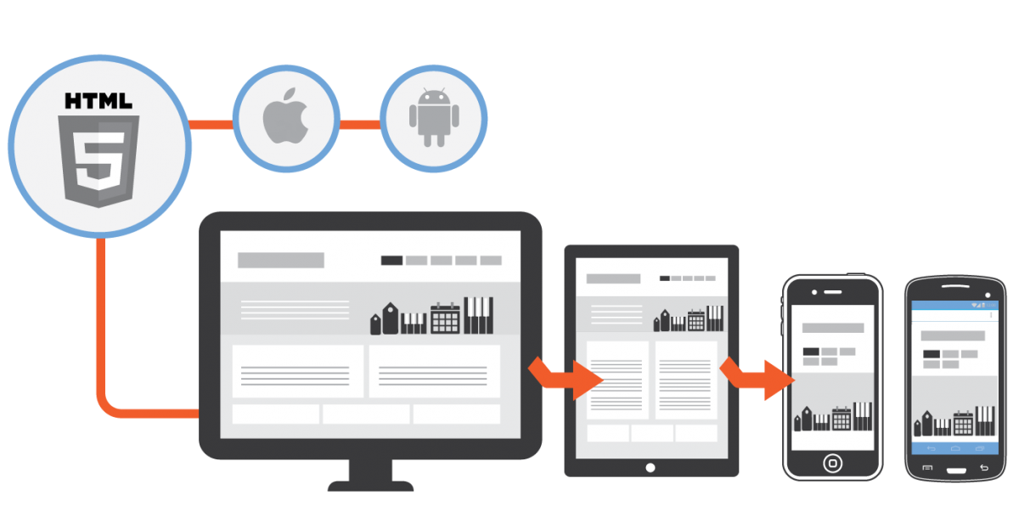

Mobile content is delivered either through an application native to the device (known as an ‘app’) or through web protocols, or some combination of the two. The following are the major content delivery protocols today:

- iOS - the standard developed by Apple for use on the iPad and iPhone. Apple apps are exclusive to Apple devices and are distributed through the Apple store. - http://www.apple.com/ca/ios/ios-10/

- Android - the open source operating system developed by Google and used on a wide variety of devices, including Samsung, HTC, and more recent versions of Blackberry. Apps are distributed through Google’s Play store. https://www.android.com/

- Windows Mobile - developed by Microsoft beginning with Windows 8 and designed for its Surface tablets, and also used on Nokia smartphones. https://www.microsoft.com/en-ca/windows

- Web - a combination of HTML, Javascript and CSS. A variety of web frameworks for mobile exist, including especially HTML5. https://www.w3.org/TR/html5/

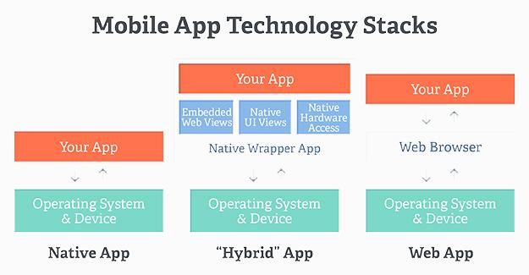
There is no significant technical barrier to developing for any platform; a large lumber of mobile development platforms and software development kits (SDKs) exists. Technology websites such as InfoWorld (2016) or TechWorld (2016) offer lists and reviews of these platforms. Microsoft developers will use an integrated development environment (IDE) like VisualStudio.

While there are reasons to develop native apps, the drawback is that they run only on the platform they were designed for - iOS, Android, etc. An alternative adopted by many mobile developers is to design in HTML 5. Numerous HTML5 user interface (UI) frameworks exist. (Neotic Force, 2016) HTML 5 applications can also access data from the wider web, including content delivery networks, cloud-hosted databases, and data services.

Learning technology standards also play a significant role in mobile learning. The first major harmonization of standards occurred with the development of the Advanced Distributed Learning initiative (ADL) Sharable Content Object Reference Model (SCORM) (2004), which standardizes both learning object metadata (previously described by AICC, IMS (2000), IEEE 1484 (2002), and others) and interoperability between the ‘learning object’ and the learning management system (LMS) by means of a ‘wrapper’ (harmonizing various Javascript profiles and OS-specific protocols such as CORBA).

ADL is in the process of developing a new set of standards under the heading of ‘Total Learning Architecture’ (TLA). (ADL, 2016) The first part of this is the Experience API (xAPI, formerly known as Tin Can) for the interchange of learning activity records. The new standard will expand learning resource interoperability to include new delivery modes, such as games and simulations, and new forms of interactivity, such as tactile response.

Mobile Device Management
Mobile devices are either institutionally managed or self-managed. Various configurations of device infrastructure and support exist.

When devices are institutionally managed, as for example when they are acquired to support classroom instruction, they can be configured to exactly the right specification to support learning needs. By the same token, however, this can create a need to provide systems such as laptop carts or charging stations. See, eg., the options the Vancouver School Board provides schools. (Storage Options, 2017)

Systems where devices are self-managed are known colloquially as BYOD - Bring Your Own Device. (Siddiqui, 2014) Various corporate configurations may exist:
- Unlimited access for personal devices.
- Access only to non-sensitive systems and data.
- Access, but with IT control over personal devices, apps and stored data.
- Access, while preventing local storage of data on personal devices.
(IBM Mobile, 2016)
In a business or professional context devices are frequently corporately owned and personally enabled (COPE). Many Government of Canada devices, such as personal Blackberries or individual laptops, are provided this way. “A 2016 survey of more than 400 IT decision makers in the United States reveals that nearly 80 percent of respondents provide smartphones for at least some of their employees to use for work, and around 65 percent offer tablets for business use.” (Samsung, 2016)

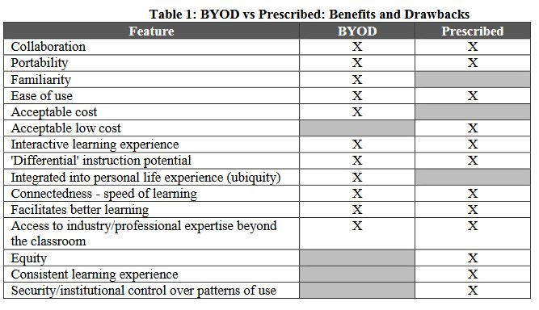Reid and Pechenkina, 2015

It is likely that in either environment an expectation of support for both employee owned and corporate owned devices will exist. Research suggests that students with access to both “use their owned and loaned devices simultaneously and in a complementary manner rather than choosing to use one device for all learning activities.” (Reid and Pechenkina, 2015) This suggests that preconfiguring institutionally-owned devices will not be sufficient, even in cases where all employees have access to institutionally-provided devices.

Accordingly it will be necessary to anticipate the challenges raised by BYOD. (Farley, et.al. 2015) “Course materials are rarely optimised for use on smartphones, navigating websites and learning management systems becomes a scrolling nightmare, and interacting with other students is often impractical using prescribed systems.”

If BYOD is indicated for support for institutional learning, a BYOD policy may be required. (Siddiqui, 2014) Even where the details of a BYOD policy may be handled by individual departments, from a learning perspective, a BYOD policy needs to balance usability and control. (Neff, 2013)

Learning With Mobile Technology
Learning with mobile is not the same as learning in a classroom or even learning with a desktop web browser. As mentioned above, mobile learning brings with it unique affordances. Additionally, it poses pedagogical challenges by virtue of smaller device size and the increased likelihood of distraction while being used.

Key issues raised by the Enhancing Workplace Learning through Mobile Technology’ was a two-year project funded by the Australian Government Office for Learning and Teaching (OLT, 2016) include:
- Planning learning experiences
- Using personal mobile devices professionally and safely
- Initiating dialogue
- Establishing networking activities
- Creating learning activities on the go
- Deepening reflection
- Considering issues of time and place

Observations of mobile learning: A university-wide survey on students’ mobile learning practices showed that ownership of mobile devices is high among students and that tablets are the most popular devices for academic purposes. (Chen and DeNoyelles, 2013)
- The survey also found that mobile learning typically occurs outside the classroom, with only limited guidance from instructors.
- To improve mobile learning effectiveness, students and instructors need help adopting more effective learning and teaching practices across content areas.
The take-away from both these studies is that students cannot be assumed to have mobile-learning skills based on their experience with other forms of learning. Therefore learning with mobile technology requires specialized assistance and support. (Shih, 2007)

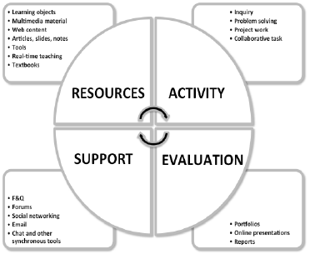
The process of learning using mobile technology, as with any form of learning, is more than mere presentation of content to be remembered. Hence we see the development of mobile learning frameworks, such as the RASE framework (standing for Resources, Activity, Support, Evaluation) (Churchill, Fox & King, 2015). “Central to RASE is the emphasis on the design of activities where students engage in using resources and in the production of artifacts that demonstrate learning.” (Churchill, Fox & King, 2013)

In addition to more traditional conceptions of learning as a dedicated activity, mobile learning can also be viewed as a form of performance support; indeed, this may be one of the major advantages. (Woodill, 2014) Performance support requires context-specific delivery of resources and support (including person-to-person support) in varied environments. Context-awareness is therefore a significant feature of mobile learning technology.

Mobile learning (and e-learning generally) benefits from being integrated into other applications. For example, job-finding sites naturally extend to mobile learning support, such as at LinkedIn, which links employment to learning opportunities on Lynda.com; similarly, the National Research Council engaged in a project to support the Treasury Branch Secretariat’s Micromissions, which are integrated into the GCConnex Elgg-based platform. (GitHub, 2016)

Content authoring for mobile
Content authoring for mobile learning environments is supported through learning development reference models and through authoring technology.
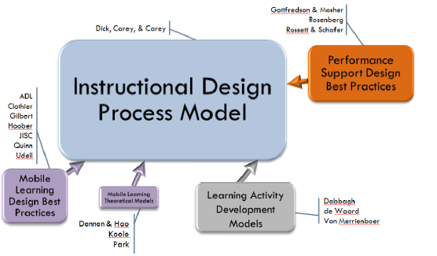
The Advanced Distributed Learning Reference Model for Designing Mobile Learning and Performance Support is a standard in the field. The authors (Berking & Haag, 2015) describe it as “a comprehensive attempt to integrate a curated collection of existing models and practices.” The core model is based on Dick & Carey model (1978) and supplemented with research specifically addressing mobile affordances. View their presentation (2016) for explanation and resources.

This approach supports work in the mobile learning process, including RASE and Shih’s (2007) model describing a five-stage learning process: attention; relevance; relevance, confidence; confidence and satisfaction.

Numerous applications support the mobile software authoring process. These applications are typically commercial in nature and require enterprise licenses. Output varies from Fash to native mobile applications to HTML5. Several of the tools, such as Storyline 360, have migrated to a subscription-based cloud environment.

Mobile Learning Resource Authoring Systems

- Adobe Captivate
- Articulate Storyline 360
- Composica
- Elucidat
- iSpring Suite
- Lectora Inspire / Online
- Microsoft Learning Content Development System (LCDS)
- Raptivity
- Xerte - Apereo Foundation

Several vendors offer ‘rapid e-learning tools’ based on design aids or templates (Coetzee & Smart, 2012; see also Ravi, et. al., 2015). These are often realized as a quick Flash animation. On a 4K screen. These animations appear like postage stamps in the middle of the screen. Designers, however, should create learning resources that can be viewed well on any screen - from a tiny handheld to a living-room television.

As support for mobile learning is extended to support increased modalities and greater affordances of mobile devices, additional learning design methodologies are required. For example, the Ambient Information Channel (AICHE) model (Specht, 2009) describes a four-layered approach to support contextual learning: the sensor layer, the aggregation later, the control layer and the indicator layer.

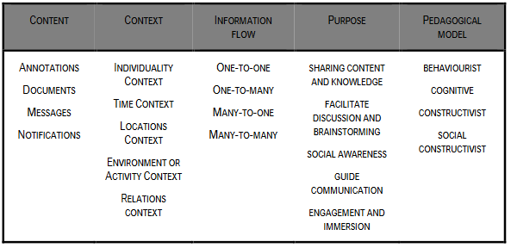

Some implemented applications (Specht 2014, in Ally and Tsinakos, 2014, ch 5 )
of the AICHE model include:
- Time-Based Notification for Reflection Support
- Location-Based Fieldwork and Data Collection
- Energy Awareness Displays

Criticisms and Failures of Mobile Learning
The development of mobile learning technology has not been even and there have been some high-profile failures. Perhaps the most notable of these is the case of Luminosity Brain Training systems. Though offered as a research-based solution (Hardy & Scanlon, 2009) it was criticized for producing no discernable learning effect. (Redick, et. al., 2013)

This points to a need for caution regarding the prescriptive claims of mobile elearning vendors. The effectiveness of mobile learning is something that bears further study. (Haag, 2011) Issues of varied learner attitudes, quality versus poorly designed courses, video playback issues, and more, all deserve further consideration.

Another criticism is that resources authored for e-learning lack learner generated content, especially with timely, relevant, and location aware examples. (Kinshuk & Jesse, 2013) Yet “The conversational nature of mobile devices and their capabilities to capture and transmit multimedia data (photos, video, audio and texts) make them suitable to collaborative development of learning objects.” (Castillo & Ayala, 2008)

Student experiences using mobile devices in varied environments need to be structured in order to enable the best learning outcomes. (Hwang, Hu & Ke, 2011) “Without effective tools for helping students organize their observations in the field, the mobile learning performance could be disappointing.” Scaffolds such as concept maps or other experience management frameworks may be required in such situations.

The Future of Mobile Learning
Two major advances in mobile learning will most likely impact future developments in the field.

The first, already mentioned, is the development of context-based applications. This is currently being explored by numerous researchers. One aspect of competency is existing learner mastery, examined with respect to adaptive and applied learning (eg. Wu, et al, 2011). Another aspect is the modeling of the data provided by environmental sensors (eg. Tortorella, 2013, p., 42) Context can also be defined procedurally, as for example within a business process. (Valentin, et.al, 2014) (WISE, 2017)

The second relates to the embedding of mobile learning technology in devices. According to a recent Futurelab (2007) report, for example, by 2020, digital technology will be embedded and distributed in most objects. We will not be taking any devices with us, they will exist everywhere. “All personal artefacts – your keys, clothes, shoes, notebook, newspaper – have devices embedded within them which can communicate with each other.”

Mobile Learning: Current State of the Art

Research Questions to be Posed

- What elements defined mobile learning for CSPS?

- What data is there on mobile device employment in the Canadian public service

- Are mobile policy frameworks in place, or, what would the process be for developing one?

- Has CSPS adopted mobile delivery standards? Are others extance in the Canadian public service?

- Do the resources exist for device provision, or can accommodations be made for BYOD (Bring Your Own Device)?

- What pedagogical principles inform CSPS, and are they consistent with mobile delivery?

- Does CSPS have the capacity and tools to author for mobile (eg., for Apps? for HTML5)?

- Do existing CSPS assessment and quality control standards map to mobile learning?

- Does CSPS have the capacity to adapt to future technologies, such as embedded software or context-aware devices?

Personalized Learning

Current State of the Art

What is Personalized Learning?
Definitions of ‘personalized learning’ focus on optimizing learning through reference to personal properties or needs.

The U.S. Department of Education National Education Technology Plan Update describes it thus: “Personalized learning refers to instruction in which the pace of learning and the instructional approach are optimized for the needs of each learner. Learning objectives, instructional approaches, and instructional content (and its sequencing) may all vary based on learner needs. In addition, learning activities are meaningful and relevant to learners, driven by their interests, and often self-initiated.” (NETP, 2017)

Feldstein & Hill (2016) describe personalized learning in terms of three major practices:
- Moving content broadcast out of the classroom
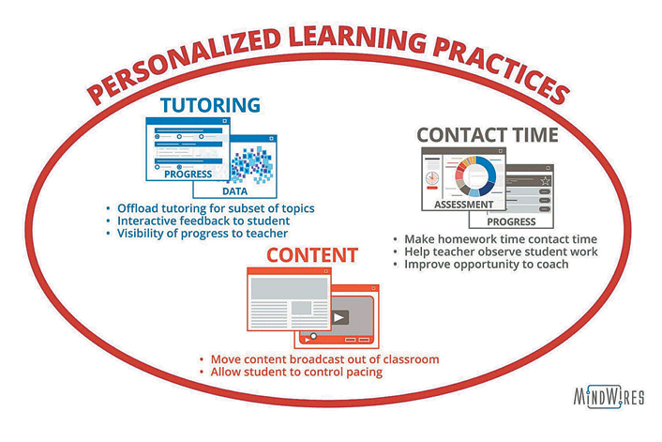
- Turning homework time into contact time
- Providing tutoring

Though the Feldstein & Hill definition is directed toward traditional educational institutions, the emphasis and approaches based on content, support and activities can be employed in a wider context,

Maggio and Stranack (2016) identify four major lines of development and research needs in personalized learning:

- Personalized learning at scale need not rely solely on predictive analytics — it can be facilitated by connecting and empowering distributed communities of learners to co-create their learning experience.

- Many students are not prepared to engage in personalized, connected learning and require clear messaging about the vision, values, and skills that will help them succeed.

- Personalized learning requires a delicate balance between student autonomy and instructor-led direction and scaffolding, along with openness as a pedagogy and toward content licensing, to achieve personalized, crowdsourced, connected learning.

- The most effective personalized learning at scale requires the thoughtful integration of many pedagogies and emerging technologies including learning analytics, openness, and connectivism.

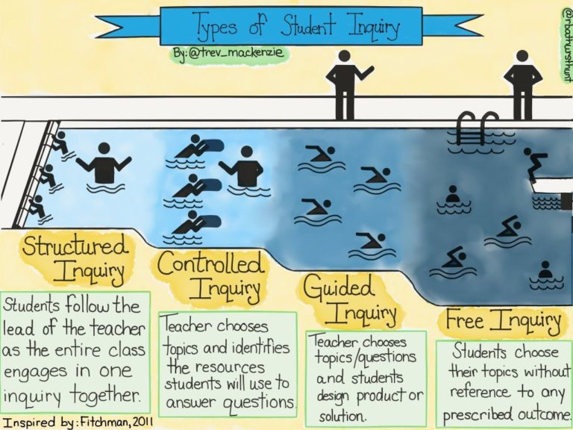
The Gates Foundation (2016) has driven many of the innovations in personalized learning in K12 education. It defines ‘personalized learning’ in a much more teacher-negotiated manner. “In personalized learning settings, teachers assess students’ strengths and needs to create learning plans that are aligned with each student’s interests, while maintaining strong academic standards.”

It is perhaps best to define ‘personalized learning’ as a range of approaches, which different properties, varying depending on learner needs and instructional mandates. (Dana Fichtman, Thomas & Boynton, 2011) For example, personalized learning may be structured, controlled, guided or free. (MacKenzie, 2013)

Vendor Innovations and Technology Investment Drivers
Vendors supporting personalized learning are responding to a number of drivers in both performance management and in learning and development. (Gartner G00266384, 2015).

Performance management
- shift in performance management processes from annual or periodic reviews to more frequent employee check-ins
- strong desire to foster better employee/manager communications and broaden it beyond current organizational teams with increased peer-to-peer feedback and engagement
- addition of more social and informal feedback support, improved goal visibility, and a focus on the dynamics of how successful teams are created and engaged

Learning and development
- new tools for coaching and mentoring
- new tools for social and video-based learning
- rise in tools or platforms that support the capture and sharing of recognition moments and/or foster wellness

Imaginarium (2016), the Denver Public Schools’ innovation agency, describes drivers in detail across four dimensions:
- Learner paths - “matching learner interests with learning needs”
- Evolving teacher and learner roles - “promote learner agency as facilitators and guides”
- Strategic resource use - “integrate family and community partners into learners’ educational experiences”
- Developing, demonstrating and deepening competencies - “engaging in standards-aligned and authentic experiences”

Competencies and Talent Management
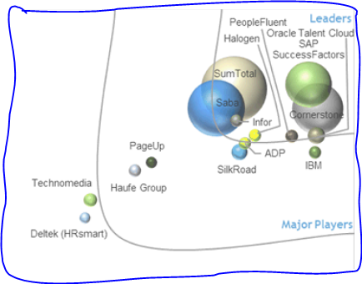
Personalized learning in professional contexts is often associated with competencies and talent management. Talent management (TM) is an established technology sector. TM suites support a variety of capabilities and are typically composed of four or more of the following applications:
- Workforce Planning
- Recruiting and Onboarding
- Performance and Goal Management
- Learning Management
- Career and Succession Planning
- Compensation Management

See also Bersin’s analysis of Talent Management companies (Bersin, 2016)
Image: IDC, 2016
The use of competencies may be viewed
as an effort to formalize talent management. A competency is (on some accounts) a semantic representation of the skills recognized in learning and performance support. This model is essentially a set of hypotheses about a person’s performance, and mechanisms for testing and verifying them. (Hirata & Laughton, 2012) Competencies are described by ISO/IEC JTC1 SC 36 in terms of nine information object classes, including action, role, outcome, assessment process, method and criteria, and environment. (ISO/IEC 20006-1:2014)

In the Canadian public sector the framework is based on the existing job classification system in place within the Canadian public service. The article indicates numerous core competencies for all public sector employees (making up more than 140 competency profiles). The competency framework is available through the CBM (Competency Based Management) Web Suite 2, accessible to all employees. (Bonder, Bouchard & Bellemare, 2011; see also TBS 2016 and TBS 2016a)

As a part of its Total Learning Architecture, Advanced Distributed Learning is in the process of defining a Competencies and Skills Systems (CASS) program. (ADL, 2016) The purpose of CASS is to support competency portability, to support common reporting specifications, and to support resource alignment. CASS is also coordinating data models with the Lumina Foundation's Credential Transparency Initiative. (Lumina, 2016)

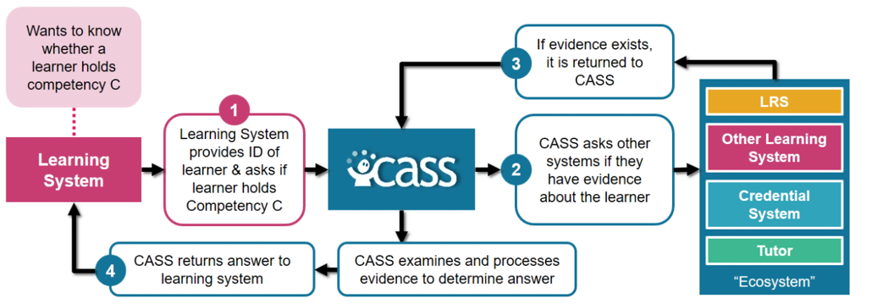

A major shortcoming of the competency management and competency based training in the workplace is the absence of a direct mechanism to translate informal learning into the competency management framework infrastructure. This creates a problem since between 70 and 90 percent of work-based learning is informal and 87 percent of Americans say Internet helps them learn new things. (Vinson, O'Donnell, Kondratova & Fournier, 2015) The 2016 Gartner report on business trends impacting higher education claims that competency-based education is currently at the peak of inflated expectations at the digital learning technologies hype curve.

Competency Frameworks
Numerous competency standard and frameworks projects exist; we can represent only a small number of them here, as examples.

- Australian qualifications framework
- General capabilities in the Australian Curriculum
- Australian curriculum
- NRC Competency Profiles
- OECD Core Competency Framework - (Also)
- European Competency Framework
- IEEE Software Engineering Competency Model - Presentation
- IBM Kenexa Competency Frameworks
- ONet Online & CareerOneStop
- Competency Model Clearinghouse
- CareerOneStop pyramid model
- National Occupational Classification 2011 the authoritative resource on occupational information in Canada
- Mission essential competencies. Air force- Marine operations
- TRADEM-SEM - - validate domain and expert models
- Association of American Colleges & Universities - Value Rubrics

General competency framework and reference models include the following standards and specifications:
- ISO/IEC 24763 (2011) – Conceptual Reference Model for Competencies and Related Objects
- ISO/IEC 20006 series – Information Model for Competency
- Part 1: Competency general framework and information model (2014) –
- Part 2: Proficiency level information model (2015) -

The proliferation of competency frameworks and specifications ensures that personalized learning systems based on competency management will need to be able to work with and translate between various representations..

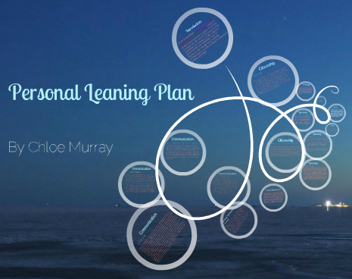
Personal Learning Plan
The idea of the personal learning plan predates instructional technology and is a widely employed mechanism to personalize learning. “The ability of a learner to develop a personal learning plan in some ways different from that of other learners, or the ability to find resources for study in one’s work or community environment, or the ability to decide for oneself when progress is satisfactory, should not be treated as extraneous and regrettable noise…” (Moore, 1994) (Image)

These three elements - the development of a plan, the selection of resources, and self-evaluation - form the basis for contemporary personal learning plan technology.

Several companies and institutions have developed learning path solutions, including
- Illuminate Education - data-based learning path
- FilterED Global Filter - specializes in rapid personal path creation
- MiCLUES - creates personal learning paths through museums and exhibits
- ItsLearning - learning platform
- Apereo OpenSSP - student success plan

A full discussion of personal learning resource recommendation is beyond the scope of this document. Numerous solutions exist, including many based on collaborative filtering technology (the same technology that runs matchmaking sites, movie recommendation sites, and the like). Some recent work involves human cognitive modeling (Kopeinik, et.al., 2016), attribute-based collaborative filtering (Salehi, 2013), and tag-based collaborative filtering (Chatti, et.al., 2013)

Similarly, personal evaluation and assessment is a large industry unto itself and is beyond the scope of this article. Scholarly work and applications exist in almost all domains, including employee self-assessment (HBR, 2013), needs assessment and learner self-evaluation (Shepard, 2000) , and learning outcomes (Zimbroff, Taylor & Houser, 2016) Personal self-assessment typically requires an assessment instrument such as a quiz or survey, or even a physical sensor, and an evaluation rubric set against goals, standards or averages.

Adaptive Learning
Adaptive learning is a subset of the previous section and is based on technology that ‘adapts’ to changing circumstances during the course of a sequence of learning events. Adaptive learning is also a subset of the wider field of ‘learning analytics’.
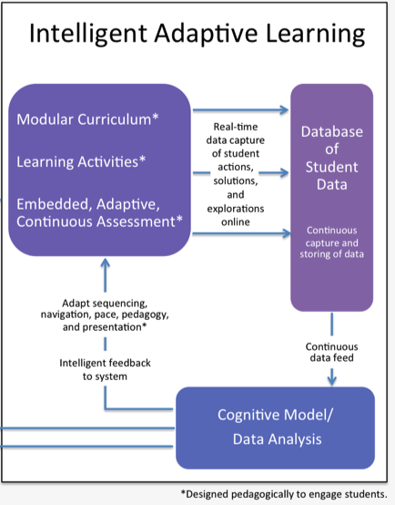
Some examples of adaptive learning include:

- Prodigy - math game that adjusts questions (Prodigy Blog, 2016)
- ClassK12 - prepare for standardized tests such as SBAC, PARCC
- McGraw-Hill - has included products like ALEKS and Connect
- Knewton - adaptive learning path platform
- Brightspace LeAP - spots areas of difficulty and recommends resources
- Dreambox - modifies presentation of learning materials based on student input
- LoudCloud - collaborative open content recommendation
- RealizeIt - mastery-based personal learning path
- Fulcrum - competency-based premium content

An adaptive learning system is a combination of several technologies (Lemke, 2013):

- Modularization of learning content - whether it’s called ‘learning objects’ or ‘microlearning’ the concept is that smaller pieces of learning content can be arranged in different ways
- Learning activities - adaptive learning typically engages a learner into a process of learning, which in turn produces continuous feedback
- Continuous assessment - an adaptive learning system requires input data in order to make recommendations and on which to base future recommendations
- Learning analytics - an adaptive learning system will compile a database of student data in which to apply collaborative filtering algorithms
- Cognitive model - an optional (but almost always utilized) data structure that helps machine learning manage and understand student data

Informal Learning

·

Credentials, Badges

Blockchain’

Personal Learning Records

· W3C – Activity streams - https://www.w3.org/TR/2016/CR-activitystreams-core-20161215/
o Vocabulary - https://www.w3.org/TR/2016/CR-activitystreams-vocabulary-20161215/
· xAPI
o Rustrici - http://rusticisoftware.com/
− Tin Can SAPI - http://tincanapi.com/overview/
− Cf. Learning Technologies Group PLC
o ADL – Experience API - https://www.adlnet.gov/adl-research/performance-tracking-analysis/experience-api/
o xAPI software - https://github.com/adlnet/xAPI-Spec/blob/master/xAPI-Communication.md
o CMI5 - https://elearningindustry.com/mobile-learning-code-xapi-and-cmi5 - The cmi5 specification defines how learning content is imported, launched, and tracked by the Learning Management System using an xAPI LRS. It was developed with these goals:
· IMS Caliper Analytics - https://www.imsglobal.org/activity/caliperram
· Apereo – open source learning record store - https://www.apereo.org/communities/learning-analytics-initiative
· Yet Analytics - http://www.yetanalytics.com/ - LRS
o Certification

Automated personal profile creation - variety of means, eg:
- Personal profile mining based on mobile phone location data - http://dx.doi.org/10.13203/j.whugis20130066
- User profile extraction from Twitter for personalized news recommendation - http://dx.doi.org/10.1109/ICACT.2014.6779068
- Eliciting teachers ICT competence profiles based on usage patterns within learning object repositories - http://dx.doi.org/10.1109/T4E.2014.19

Personal Digital Archiving
o E-portfolio
o Reference management: Mendeley Zotero, PaperPile

· Library of Congress - http://www.digitalpreservation.gov/personalarchiving/
o Kit to hold your own PDA day event - http://digitalpreservation.gov/personalarchiving/padKit/index.html
· Columbia University Digital Humanities Center – PDA online resources - http://library.columbia.edu/locations/dhc/personal-digital-archiving/online-resources.html
· Cornell University - guide from Cornell University is based on the workshop “Personal Digital Archiving - http://guides.library.cornell.edu/digitalarchiving
· Patradigm Project - guidelines for the creators of personal digital archives - http://www.thedigitalbeyond.com/
· The Digital Beyond is a blog about your digital existence and what happens to it after your death - http://www.thedigitalbeyond.com/
· PDA Conference archives - http://personaldigitalarchiving.com/past-pda-conferences/
· See also:
o Rethinking Personal Digital Archiving, Part 1, Four Challenges from the Field, Catherine C. Marshall (2008).http://www.dlib.org/dlib/march08/marshall/03marshall-pt1.html
, Implications for Services, Applications, and Institutions http://www.dlib.org/dlib/march08/marshall/03marshall-pt2.html
free PDF e-book. Perspectives on Personal Digital Archiving (2013) - http://www.digitalpreservation.gov/documents/ebookpdf_march18.pdf

Personal Learning Environment (PLE):
o Projects: CETIS Plex (not Plex Media server, that’s different), ROLE
o Personal E-Books for Learning (PEBL)

Personal Assistants

Javier (2017) surveys the strengths and weaknesses of various chatbot platforms. "The chatbot ecosystem is moving very fast and new features are being released every day by the numerous existing platforms." There are non-technical platforms aimed at average users: Chatfuel, ManyChat, Octane Ai, Massively and Motion.ai. These, though, do not have natural language processing ability and are not suitable for commercial applications. The five major solutions are all from major companies (not surprisingly). They "represent already a standard or at least they are on (their) way to become one: Api.ai (Google), Wit.ai (Facebook), LUIS (Microsoft), Watson (IBM), Lex (Amazon).

A framework of an agent-based personal assistant for internet users - http://dx.doi.org/10.1007/978-3-642-13480-7_18

Existing Knowledge and Capabilities

Research Questions to be Posed
- how does CSPS define personalized learning, or is there a working definition in place?
- what existing tools does CSPS employ for performance management, and learning and development?
- has CSPS adopted a talent management framework or management system?
- what definitions or management frameworks (if any) for competencies does CSPS employ?
- are CSPS talent and competency management systems linked to external services, such as job or placement-finding sites?
- can CSPS support and manage personal learning plans or learning paths? Automated?
- what approach to and/or technology does CSPS support for content & learning recommendations?
- What support does CSPS currently provide to support informal learning?
- does CSPS support personal learning records, and to what granularity (eg., do they store activity records? personal portfolios?)
- does CSPS provide upload or storage for personal profiles or personal data archiving?
- are there automated mechanisms in place for profile creation and assessment?

Shared Learning Space / Crowd-Sourcing

Current State of the Art

What is Shared and Crowdsourced Learning?
The idea behind ‘crowdsourcing’ is that authorship or creativity is vested in many people - the ‘crowd’ - rather than from one authoritative source. As we see in this section, crowdsourcing is a combination of several themes: open learning, shared environments, social networks and crowdsourced production.

It has been argued that “The basic concept behind crowdsourcing comes from a June 2006 article by Jeff Howe for WIRED.com (Howe, 2006) in which he described the phenomenon as a new and innovative business plan borrowing from the Wiki model and outsourcing.” (Marquis, 2011) The mechanics of crowdsourcing predate even this article; Amazon’s Mechanical Turk, for example, which farms out small tasks to tens of thousands of workers, was founded in 2005. (Marder & Fritz, 2015)

In education, crowdsourcing is the idea that learning “can be facilitated by connecting and empowering distributed communities of learners.” (Maggio & Stranack, 2016) It is based on the use of social networks in learning and especially content production. (Downes, 2005) The attempt to crowdsource learning production and support gave rise to the first Massive Open Online Courses (MOOCs) in 2008.
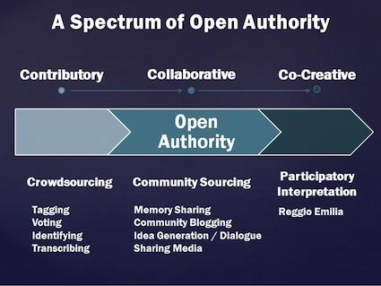
Crowdsourcing is not one approach, but rather a family of approaches. These may vary from close collaboration toward a common objective, as in the case of Wikipedia, or loose cooperation toward distinct objectives, as in a community of practice. This tension is evident in the literature:

“Mia Ridge, a doctoral researcher at the Open University and editor of the forthcoming book Crowdsourcing Our Cultural Heritage, defines crowdsourcing as asks directed toward a shared goal that cannot be done automatically and which have inherent rewards for participation. But crowdsourcing is just one facet of a wider spectrum of Open Authority, with deeper levels of collaboration and dialogue occurring between experts and community members as the spectrum progresses.” (Phillips, 2014)

Open authority can be manifest through varying applications. Loose contributory crowdsourcing models include tagging, voting, identifying and transcribing. Community sourcing can include memory-sharing, blogging or dialogue and discussion. Participatory interpretation involves co-creation, as in a wiki, community art projects, making, hackathons, and community science.

The Wisdom of Crowds
The theoretical foundation of crowdsourcing in education is found in social network theory, popularized by James Surowiecki in his book The Wisdom of Crowds (2004). The book is based on the observation that connected networks of individuals self-organize. That that the aggregated decisions of such self-organized groups are often better than any single member of the group, including expert members of the group.

The synchronicity of networks, including social networks, is widely observed. The mechanisms of connectivity are described in graph theory (eg., Wrinkler-Prins, nd) and social network theory (Watts, 2003). Computationally, the effects can be observed in neural network software, a branch of theory called ‘connectionism’. (Rumelhart & MacClelland, 1986) Educational approaches based on this theory are classified under the heading of ‘connectivism’ (Siemens, 2005), though neural-network based models of constructivism and actor-network theory (ANT) also exist.

Arguably, any interconnected network of entities will exhibit synchronicity, and thus we could consider commodity markets, the electrical grid, and population diffusion all to be examples of connective behaviour. However, as Surowiecki notes in his book, not all networks will exhibit wisdom. Networks must be constrained and power distributed. Surowiecki lists the following requirements: diversity, independence, decentralization and aggregation. In learning theory Downes describes these requirements as autonomy, diversity, openness and interactivity (Mackness & Williams, 2010).

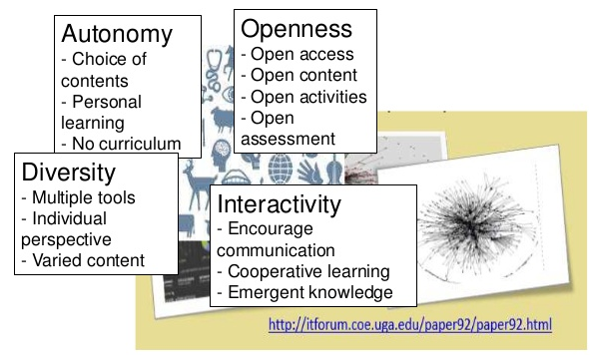

Models
Models of crowdsourced and social learning guide the development of technology and pedagogy. Some principle models are as follows:

- Seek Sense Share framework - ‘seeking’ refers to “finding things out and keeping up to date”, ‘sensing’ refers to “how we personalize information and use it,” and ‘sharing’ refers to “exchanging resources, ideas, and experiences with our networks as well as collaborating with our colleagues.” (Jarche, 2014)

- ADL Open Social Learner Model (OSLM) - employs “open social learning modeling and adaptive navigation support in the context of the envisioned Personal Assistant for Learning system.” (ADL, 2015)

- IEEE Resource Aggregation Model for Learning, Education and Training (RAMLET) - (Verber, et.al., 2016)

- ARRFF - Aggregate, Remix, Repurpose, Feed Forward (Downes, 2016).

In evaluating models, it is useful to consider the range of authority and autonomy enabled; frequently collaborative systems are described as crowdsourcing, however the models above would favour to some degree models based on cooperation.

Models should also consider success factors, for example, the following list (Maddrell, 2016):
- Use a real-world instructional design challenge.
- Create a clear design guide.
- Introduce open licensing.
- Create an understanding of the learner.

Environments

Outside learning theory, technology-enabled models of crowdsourcing abound, including distributed authoring and versioning (DAV) and source version control (Subversion, GitHub). No exact analogy exists in education technology, although a variety of tools has been used to support crowdsourced learning:

- Open learning, eg., Apereo Open Academic Environment
- Cloud Technologies, eg. IBM Kenexa, Oracle Taleo
- Virtual Classrooms, eg. Connect, Collaborate, Cisco (Spark, WebX)
- Social networks for learning, eg. Elgg
- MOOCs, eg. gRSShopper, Udemy

Numerous sites also support contributory models of crowdsourced learning. In this context, such an environment would consist of learning resources created by and deposited into a common environment by a community.
Various contribution-based open course libraries (MOOCLab)

- Coursmos -micro-learning platform
- Eliademy - free & paid online courses with real-time discussions and task management
- iTunes U - free educational app with audio and video resources from top universities
- Open Education powered by Blackboard - Free online courses from Blackboard's global community of clients
- OpenLearning create, run and enrol in a course.
- Udemy create and run online courses.
- YouTube Edu - video-based courses

An example of this is the DS106 assignment bank. The Digital Storytelling (DS) course at Mary Washington university requires that students complete creative assignments. Ideas for assignments were collected and stored in an assignment bank such that students in the course could select and complete the assignment of their choice. (Levine, 2016)

Another example is the ‘folksonomy’. This is a mechanism for creating a taxonomy describing resources through individual and autonomous contributions from a community. Rather than select from a canonical list of terms, participants select whatever term they wish, creating the taxonomy and categorization at the same time. (Hammond, et.al., 2005)

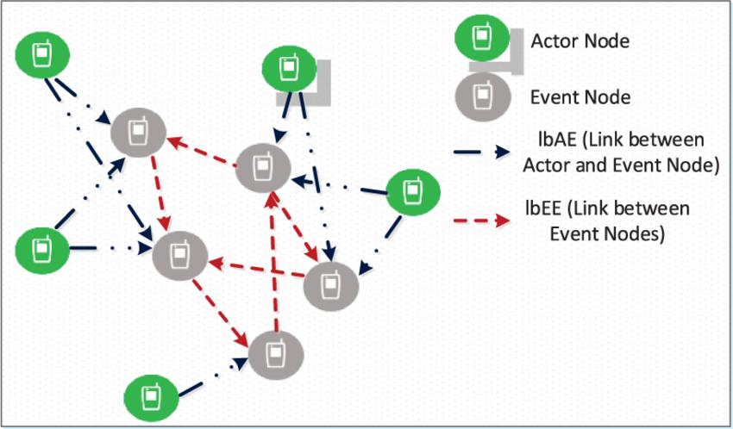
Social Network Formation and Management
As can be seen from the examples above, crowd-sourcing requires the formation of a crowd, and this is accomplished through the creation of a social network (or “networked publics” (boyd, 2007)) where individuals are linked to each other. This task, however, can be labour intensive, especially as it typically needs to be performed anew on each social network. (Image: Ahmed, et.al., 2014)

A significant area of research, therefore, exists in the area of automated social network creation and management. There are two major approaches to automated social network formation: collaborative filtering, and privacy preserving.

Collaborative filtering, as described above, involves the creation of a database of user properties, and then analysis of that data, in this case to form links (Chen, Li & Huang, 2005; Kopnstas, et.al., 2009, and many more) based on a variety of feature sets and algorithms Examples of the outcome of such approaches can be seen when social networks such as Twitter, Facebook and LinkedIn offer “recommendations” of people you should follow or friend.

Privacy Preserving social network formation is more recent and can be seen in cases such as PRivacy-aware Interest Sharing and Matching (PRISM). “PRISM enables users to discover mutual interests without revealing their interests. Unlike existing approaches, PRISM does not require revealing the interests to a trusted server.” (Abbas, et.al., 2016; Ishikuro & Omote, 2016) These approaches may employ encryption to disguise data, or maintain separation between individual accounts.

The management of social networks can be facilitated through a variety of pattern matching, clustering and deep learning technologies. An example of this is the coloration on the LinkedIn social network graph indicating various categories of contacts. Deeper analytics can infer relationship strength and social context from interaction pattern and profile similarity. (Ahmed, 2016)

Applications of Crowd-Sourcing
Although discussions of crowdsourcing typically focus on the recommendation of learning resources, it is important to take not of numerous other applications of crowdsourcing in a learning context. This section lists a few examples.

- Crowdsourcing for public engagement - In a project called The People’s Constitution and employing a tool called Crowdicity the London School of Economics (LSE) gave thousands of participants “suggest, argue for, persuade and promote any parts of the country’s new proposed constitutional order that meant the most to them.” (LSE, 2016; Raths, 2016)

- Social bookmarking and search - crowdsourcing methods assist communities to find and tag resources through folksonomies and social bookmarking services such as BibSonomy, CiteULike, Diigo. Applications include personalizing web search with folksonomy-based user and document profiles (Cantador, et.al., 2010) or interest-based selection of user generated content for rich communication services (Strobbe, et.al., 2010)

- Social learning, properly so-called, which entails the development and use of social networks in order to create learning communities using platforms such as Elgg, iVersity, Mzinga, and Edmodo. Ongoing research projects into social learning include the British Arts and Humanities Research Council (AHRC) Social Media Knowledge Exchange (SMKE) and Teach Too, which encourages industry participation in education and training.

- Project teaming and collaborative learning - using tools such as Jira, Slack, Trello or MS Teams, teams can organize and work collaboratively to develop software or other solutions. Collaborative learning is in addition the focus of numerous research projects, for example, Center for Collaborative Education (CCE), which focuses on schools, the Cornell Center for Teaching Excellence (CTE) work on group work, and more recently, collaborative game-based learning (Babu, et.al., 2016) and collaborative learning environments using augmented reality. (Cochrane, Narayan & Antonczak, 2016)

- Social media for research dissemination - projects such as the the Digital Research Video Project target “a broad movement towards increasing research accessibility across disciplines in the sciences and humanities.” (Pilaar Birch, 2013) (Image: Zhang, 2013)
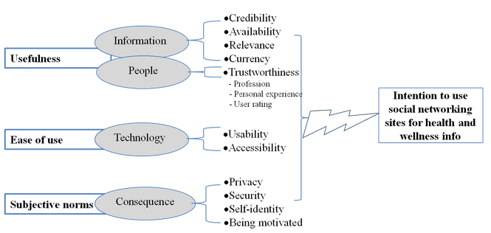

- Supporting shared spaces - such as the TidesCanada project to enhance “the capacity of Canadian organizations to create and sustain community hubs, nonprofit centres and other shared space platforms.” (Girvan, 2014)

- Scientific research - examples include Annotathon, where bioinformatics students simultaneously learn and perform metagenome annotation, and Learning from Stories, a project collecting input on mobile devices from crowds to train virtual agents, (Khan, Al-Khanjari & Sarrab, 2016) or Essex County teacher librarians collaborative inquiry.

Social Presence

Social presence in online learning communities : The role of personal profiles - http://dx.doi.org/10.3402/rlt.v22.19710 - “Social presence relates to the need for users of technology-based communication to perceive each other as real people”

Technology standards for collaboration in learning
“WebRTC is a free, open project that provides browsers and mobile applications with Real-Time Communications (RTC) capabilities via simple APIs. The WebRTC components have been optimized to best serve this purpose.” - https://webrtc.org/
ColScript a New Scripting Language for Collaborative Learning - http://online-journals.org/index.php/i-jac/article/view/4994 (proposal only)

Privacy and Security Issues
Eg. https://www.fastcompany.com/3067367/the-future-of-work/why-slack-chatbots-and-freelance-workers-have-your-it-department-freaking
One of the most serious concerns for companies in using social media for learning in the workplace is that employees might disclose company IP in the social media. It could be product information or internal work processes, workflows, company-specific training, know-how, trade secrets, etc.
When designing a personal learning environment to be used in the workplace by company/organization employees, technology developers should focus on providing tools for the employers that can help in mitigating disclosure risks for sensitive business information. Such tools could include software modules that would detect and flag risky email messages, or social media interactions containing company IP (Kondratova & O’Donnell, 2014. Internal LPSS report for the Personal cloud project)

Existing Knowledge and Capabilities

http://thealphalab.org/research.html

Research Questions to be Posed

- What principles underlie the CSPS understanding of crowd-sourcing? Open, shared, social and crowdsourced?
- If there familiarity with crowd-sourcing models (eg. Open Social Learner Model), or endorsements of any?
- What open, shared, social and crowdsourced learning environments are currently supported?
- Are there tools and/or support for automated social network formation and management?
- What applications of crowd-sourcing are envisioned? (eg. public engagement, problem solving, knowledge bank)
- Does CSPS employ teaming environments (Jira, Slack, Git, Trello) and/or offer support for these?
- What provisions are there for authorship, sharing, annotation and ratings within the CSPS social environment?
- What role does social presence and/or social presence theory play in CSPS pedagogical approaches?
- Does CSPS support common messaging, communications, or other networking protocols?
- What security and privacy constraints apply to CSPS and other GoC environments? Bilingualism?

Virtual Library

Current State of the Art

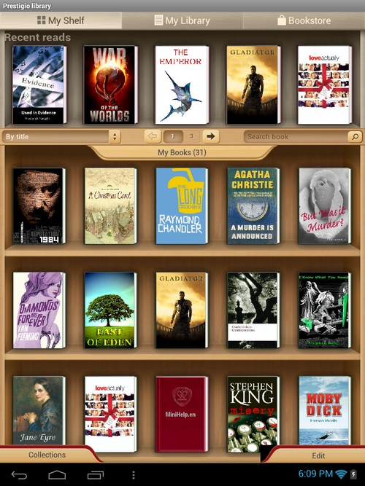
What is a Virtual Library?
The concept of the virtual library may appear intuitive, but it is useful to draw out this conception through an enumeration of core features or elements (quoted from IGI at length):

- Virtual Library is a collection of resources available on one or more computer systems, where a single interface or entry point to the collections is provided.
- The entire content of a (digital) library made accessible via the Internet. The content may come from different providers (e.g., the “German Virtual Libraries”).
- More than just a means of collocating electronic resources (full-text materials, databases, media, and catalogues), a virtual library also provides user assistance services such as reference, interlibrary loan, technical assistance, etc.
- Library resources (e.g., indexes, journals, and reference materials) or online reference services are available over the Internet. Terms such as electronic library and digital library are used synonymously.
- An entity that does not presuppose a physical existence, that only exists on the net, and that is mainly destined to signal the existence and location of electronic documents.
- Library resources (indexes, journals, and reference materials, for example) or online reference services are available over the Internet. Terms such as Electronic Library and Digital Library are often used synonymously. (IGI Global, 2016)

Examples of virtual libraries, such as the Toronto School Board, lead us to expect (and require) the following services:

- Acquisitions & Deposits - eg. GoC Depository Services
- Recommendations, Summaries and surveys - eg. Hill Noters
- Browse categories - eg. McGill’s Ecological Agricultural Products
- Search - eg., IEEE Xplore at Athabasca University
- Classifications - eg. WWW Virtual Library - http://vlib.org/
- Inquiry - eg. Library of Congress Ask a Librarian
- Tools - eg., Public Health Ontario MediQAT critical appraisal tool
- Read / View - eg. the British Library’s Turning The Pages system

Some Canadian Examples
This is only a sample of the digital library resources available from and for Canadian government and educational institutions:

- Canada Revenue Agency - virtual reading room
- Open government partnership initiative VL component - 2012
- Canadian Armed Forces virtual library -
- Department of fisheries and Oceans Virtual Library and WAVES access point -
- Judicial Affairs - virtual library mentioned but not linked
- National Research Council
  - nPARC - staff publications
  - CODES / GUIDES
  - Virtual store
- Library and Archives Canada (LAC)
  - Library and Archives Canada Action plan on open government -
  - Virtual Gramophone - Canadian Historical Sound Recordings
- Federal Science Library (FSL) portal
  - Agriculture and Agri-Food Canada (AAFC)
  - Environment and Climate Change Canada (ECCC)
  - Fisheries and Oceans Canada (DFO)
  - Health Canada (HC) / Public Health Agency of Canada (PHAC)
  - National Research Council Canada (NRC)
  - Natural Resources Canada (NRCan)
  - Health Canada (HC) / Public Health Agency of Canada (PHAC)
- Vital Statistics - births, marriages and deaths

In Canada, the development and promotion of virtual libraries is a component of the Canadian government action plan on open government (TBS, 2009). The mandate includes:

- Maximizing the release of Government of Canada open data (structured data) and open information (unstructured documents and multi-media assets) under an open and unrestrictive licence
- Ensuring that open data and open information is released in accessible and reusable formats via Government of Canada websites and services
- Establishing and maintaining comprehensive inventories of data and information resources of business value held by the department
- Maximizing the removal of access restrictions on departmental information resources of enduring value prior to transfer to Library and Archives Canada

These directives are interpreted specifically to include virtual libraries (McDermott, 2015). “Eligible data and information will be released in standardized, open/accessible formats, free of charge, and without restrictions on reuse.”

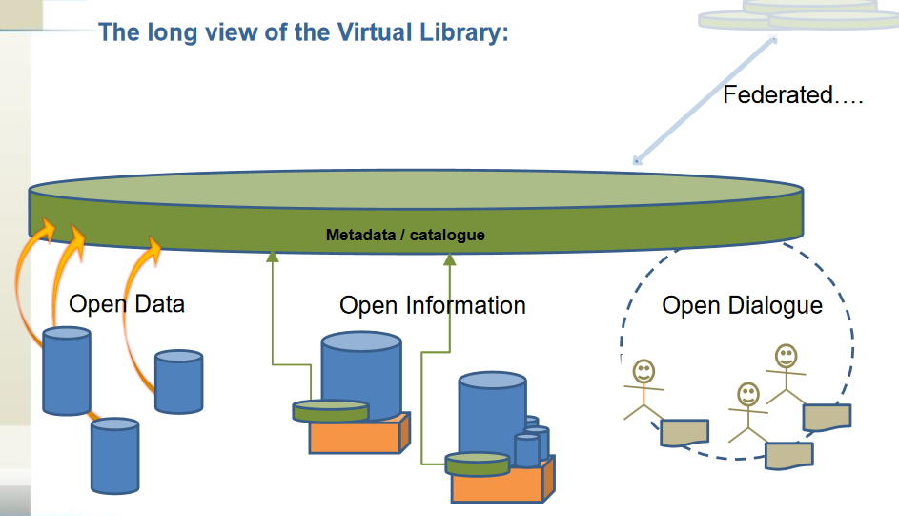

Standards and Metadata
A core component of resource management relates to standards for resource metadata. A full account of library and information services metadata is beyond the scope of this paper. However some general features may be addressed.

First, metadata serves multiple purposes and represents varied data. One way to represent different types of metadata is to consider the origins of the metadata (Downes, 2004):

- First Party Metadata - metadata created by the resource owner or publisher to describe the item, describe its provenance or membership in a larger set, and rights associated with the resource

- Second Party Metadata - metadata created by the user of the resource, and includes personal ratings and evaluations, referrals, viewing histories, annotations, citations and indexing

- Third Party Metadata - metadata created neither by end users nor by resource authors, for example, resource reviews and ratings, taxonomies and categorizations, classification

A recent document published by the The National Information Standards Organization (Riley, NISO, 2017) breaks them down as follows:

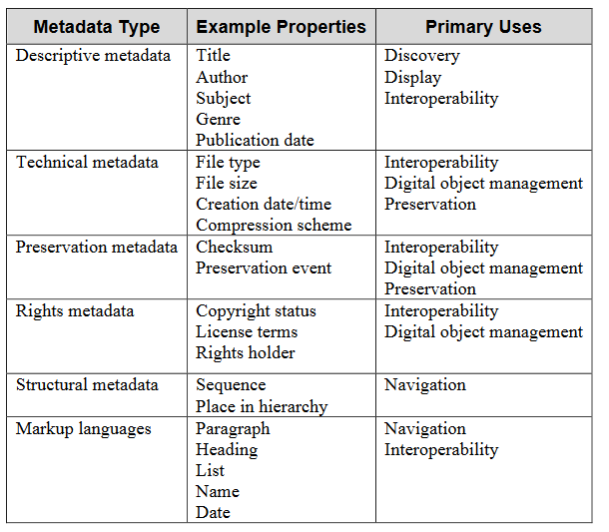

Metadata vocabularies are often restricted. Canadian examples of thesauri and controlled vocabularies include:
- Government of Canada Core Subject Thesaurus
- Library and Archives Canada Controlled Vocabularies

The Depository Services Program (DSP) is responsible for assigning ISBNs to all book-like products (monographic or non-serial publications) published by the Government of Canada. The DSP also assigns Government of Canada Catalogue Numbers to all Government of Canada publications, both monographic and serial. Publications are defined as all products, regardless of publishing medium, containing information for public consumption or for limited circulation. The application of these unique identifiers is mandatory under the Communications Policy of the Government of Canada.
- About ISBNs
- About Government of Canada Catalogue Numbers
More information is available on:
- ISSNs
- Cataloguing in Publication (CIP)

The Treasury Board Secretariat manages and maintains a TBS Metadata Initiative Community of Practice - www.gcpedia.gc.ca/wiki/Metadata_Community_of_Practice.

Metadata Representation
Metadata systems are composed of two major parts, the data model, which describes the types of data in the model and the relationships between them, and the serialization, which describes the physical (and typically machine-readable) manifestation of the metadata.

Some of the major metadata standards describing library and bibliographic metadata include Simple Knowledge Organization System (SKOS), Dublin Core, Friend of a Friend (FOAF), ONline Information eXchange (ONIX), EXchangeable Image File Format (Exif), Open Archives Initiative (OAI), Dspace, Dublin Core, IEEE-LOM, SCORM, ePub, EDUPub, Rich Site Summary (RSS).

While in recent years we have thought of ‘metadata’ as meaning ‘XML formats’, serialization actually includes a variety of physical formats:
- Plain text (eg., VCard)
- Databases (relational databases (MSSQL, MySQL, PostGre), non-relational database (Mongo), graph databases (Neo4J)
- XML
- Linked Data and Resource Description Format (RDF)
- Javascript Object Notation (JSON)

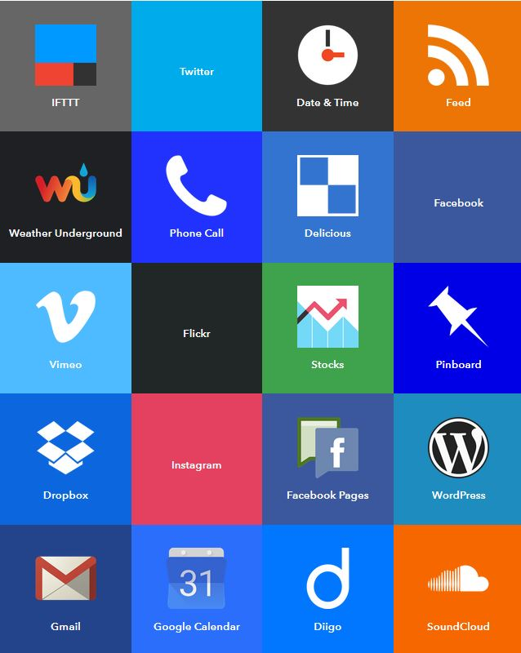
Metadata specifications themselves can be (and often are) described in metadata. Hence, for example, the RDF Schema and Ontology frameworks are described in RDF. (Horrocks, et.al., 2003)

Metadata and Resource Aggregation
- Spiders and crawlers / scrapers
- RSS
- Open Archives Initiative
- Application Programming Interfaces (APIs)
- Integration Systems (eg., IFTTT, Zapier)

Information Management / CMS
Library resources are typically houses and managed within a content management system. Some examples include:
- CMSs, such as OpenText, Lexmark
- eBooks and Textbooks / Open eBooks
- Databases – Proquest, JSTOR, etc etc
- Course Libraries
- GCcampus tools (Moodle, Drupal, Saba and other)
- EPSS – Electronic Performance Support System
- Media servers, such as Plex, Kaltura, Kodi
- App Marketplaces and Servers

Some major collections are highlighted in the next few sections. These lists are intended to be representative rather than complete.

Publication Databases

- Academia - aggregator of research papers
- Airiti - Chinese/Taiwan
- Arxiv - eprint archive
- CrossRef
- DataCite - multi-repository search
- DOAJ - Directory of Open Access Journals
- GreyNet - Grey Literature
- Igenta - users with access without any registration requirements
- JSTOR - academic journals, books, and primary sources
- LearnTechLib - Formerly EdITLib - Education & Information Technology Library
- Medical Heritage Library - JISC
- Oasis - Commonwealth of Learning
- OER Knowledge Cloud
- Paperity, a multidisciplinary aggregator of open access journals and papers
- Proquest - specialized research, eg. CBCA - Canadian Business & Current Affairs Database
- Research Gate - aggregator of research papers
- RADAR - Research Art Design Architecture Repository) is the Glasgow School of Art
- Scopus - commercial database of peer reviewed literature
- Scribd - books and papers
- SSRN - Social Science Research Network - owned by Elsevier

Course Libraries

- 360Training - blog
- Free course library -(API)
- ALISON (API)
- Allversity – dead, but courses are preserved in Dropbox and YouTube
- ApnaCourse (blog) (courses)
- Edmentum - http://www.edmentum.com/products-services
- Elsevier Sherpath - https://evolve.elsevier.com/education/sherpath/ - pre-made, course-complete adaptive courseware for nursing and health-science education ( Future of education with Sherpath)
- IEEE E-Learning Library - http://www.ieee.org/education_careers/education/elearning_library/index.html
- K12 Courseware – formerly Plato
- Khan Academy
- Learning Registry - http://learningregistry.org/ - US DoE
- LinkedIn - Lynda – http://lynda.com
- Open Learning Initiative (OLI) at Carnegie Mellon – http://oli.cmu.edu/ - courses - http://oli.cmu.edu/teach-with-oli/review-our-free-open-courses/
- Open Learning Initiative (OLI) at Stanford - http://oli.stanford.edu/ - courses - http://oli.stanford.edu/courses/
- Contact North - Study Online - http://studyonline.ca/
- OpenSesame - https://www.opensesame.com/
- Pearson MyLab & Mastering - https://www.pearsonmylabandmastering.com/northamerica/ - pre-made, course-complete courseware with online homework, tutorials, and assessments; Plural Insight - https://www.pluralsight.com/ - online library of more than 5,000 technical, design and business courses for professionals
- NightCourses - https://www.nightcourses.com/ - course finder service in Ireland
- Eukleia Training - http://eukleia-training.com/ specializing in Governance, Risk Management and Compliance (GRC) training. Cf. Learning Technologies Group PLC - http://www.ltgplc.com/portfolio/
- GO1 - https://www.go1.com/#!/ - Marketplace of over 100,000+ courses
- Seagull –http://www.seagull.no/Maritime - dedicated to shipping http://seagulloilandgas.no/ - oil and gas
- Evolui - https://www.evolui.com/ - Portugese

Open Educational Resources

· Al Masdar - http://www.arabicalmasdar.org/ -
o ISKME project page - http://www.iskme.org/our-work/al-masdar-source-arabic-teaching-and-learning
· African Storybook Project - http://www.africanstorybook.org/ - SAIDE
· BC Campus open textbooks - https://open.bccampus.ca/about-2/
o Open textbooks
· Open Professional Education Network (OPEN) - https://open4us.org/find-oer/
· Digital Humanities OER (DHOER) - http://www.ucl.ac.uk/dhoer/ - creating Open Educational Resources (OER) from a comprehensive range of introductory materials in Digital Humanities – project completed
· EU / EDEN – OpenProf - http://www.openprof.eu/
· MERLOT - http://oeraccess.merlot.org/ - https://www.merlot.org/
· Open Educational Resources Universitas
· Lumen Learning - http://lumenlearning.com/
· OpenStax (formerly Connexions) https://cnx.org/
o Textbook library
· Quizlet - https://quizlet.com/ - huge study tool library
·
· Skillscommons.org - http://support.taaccct.org/
o The US Department of Labor's Trade Adjustment Assistance Community College and Career Training (TAACCCT) program has created a free and open online library called SkillsCommons containing free and open learning materials and program support materials - http://www.doleta.gov/taaccct/
· University of Maryland’s open source textbook initiative, known as “MOST,” - http://oer.umd.edu/ - http://www.usmd.edu/cai/maryland-open-source-textbook-most-initiative
· Community College Consortium for Open Educational Resources - http://www.oerconsortium.org/
· OER Commons - http://www.oercommons.org/
· Open SUNY - http://open.suny.edu/
· UMass Amherts Libraries - http://www.library.umass.edu/services/teaching-and-learning/oer
· National Repository of Open Educational Resources (NROER) - http://nroer.gov.in/welcome - India
· Knovation - http://www.knovationlearning.com/ -
o Net Trekker - http://www.knovationlearning.com/solutions/nettrekker/ - search
o iCurio - http://www.knovationlearning.com/solutions/icurio/ - curation
· Clever - - Single Sign-On for Open Educational Resources (OER)
· Lektion.se - http://www.lektion.se/ - open learning resource library in Sweden - thousands of tips and - supplier - 248,000 members
o Resources list - http://www.lektion.se/links/
o Afrticle - http://www.openpraxis.org/index.php/OpenPraxis/article/view/336/231
· Open Textbook Network is now giving faculty a PressBooks - they are working with Hugh McGuire, the founder of PressBooks, on a $500,000 grant to create a workflow for OER called the Rebus Project.
· Lumen Learning has a platform out called Candela, also WordPress-based, which embeds in Blackboard or Canvas or another LMS via something called LTI and lets faculty directly edit a hosted web copy of their textbook.
Wikipedia – http://www.wikipedia.com

Projects
· Language Open Resources Online (LORO) - http://www.open.ac.uk/education-and-languages/loro/ - Open University - repository for language learning and teaching online and from a distance, with over 700 resources for six languages
· iTILT project (interactive Technologies in Language Teaching) - http://www.itilt.eu/
Jisc / HEA Open Educational Resource Programme - Jisc / HEA Open Educational Resource Programme - ran 2009 - 2012

Virtual Library Platforms
- ACM - Association for Computing Machinery - proprietary system that is wholly developed, hosted, and maintained by ACM - open source (?)
- EPrints - open source software used to manage the EPrints publication library
- Fedora - modular open source repository platform
- Library for All - cloud-based low-bandwidth virtual library system
- Greenstone - can publish on DVD or USB stick
- MyCoRe - open source framework for presentation and management of digital content
- Public Knowledge Project - Open Journal Systems - widely used open source software used to manage monographs, journals and events; OJS 3 was released August, 2016
- Omeka - designed for scholars, museums and libraries

Shared Library Services
Canadian library community:
- Copnsortiuum - http://www.bac-lac.gc.ca/eng/services/federal-librairies-coordination-secretariat/Pages/flc.aspx
- Discussion lists - http://www.bac-lac.gc.ca/eng/services-public/services-a-z/Pages/discussion-mailing-lists.aspx#flcs-scbgf

Shared Library Services Partnership (SLSP)
Eg. Public Health Ontario - https://www.publichealthontario.ca/en/ServicesAndTools/VirtualLibrary/Pages/SLSP.aspx

- Inter-library and inter-institutional loans
  - Loans to other institutions
  - Symbols and Interlibrary Loan Policies in Canada

Assessments and Quality Control

MetaCat critical appraisal tool
https://www.publichealthontario.ca/en/ServicesAndTools/Pages/Critical-Appraisal-Tool.aspx

Access, Copyright and Licensing Control

Access:

· Bumble- https://bumble.com/ - prove you’re real with selfies
o Article - http://nymag.com/selectall/2016/09/bumble-dating-app-rolls-out-selfie-photo-verification.html
· Classlink https://www.classlink.com/
· IMS OneRoster https://www.imsglobal.org/article/school-districts-and-suppliers-are-aligned-oneroster
· Ed-Fi http://www.ed-fi.org/
· Shibboleth - https://shibboleth.net/
o Identity federation
· Eduroam - https://www.eduroam.org/
o Supports network access when visiting participating institution
· CAS – enterprise single sign-on - https://www.apereo.org/projects/cas
· Clever - https://clever.com/
o Partnered with ISKME - http://iskme.org/media/press-releases/single-sign-open-educational-resources-oer
· Encore Technology Grou – http://www.encoretg.com
Enboard - http://www.enboard.com/

Licensing:

RightFind - http://www.copyright.com/business/rightfind-enterprise/

Existing Knowledge and Capabilities

Research Questions to be Posed
- How does CSPS define a virtual library, and what major functions does it envision a VL supporting?
- To what degree does CSPS leverage and/or is integrated with existing VLs in the GoC
- Would CSPS consider a VL to be part of Canada's wider Open Government initiative?
- What linkages does CSPS have to the GoC and wider library community?
- Has CSPS adopted internal resource metadata standards and/or tools for implementing those?
- Can other CSPS tools read, recognize and employ VL metadata records?
- What is CSPS's information and/or content management environment?
- Does CSPS employ or provide access to publication databases? If so, which?
- Does CSPS employ and/or provide access to internal and external course libraries?
- To what degree does CSPS employ open educational resources, and is there a policy regarding them?
- Does CSPS currently participate in shared library services?
- What mechanism, tools and/or standards does CSPS provide for material assessment and quality control?
- How does CSPS manage Rights / Language / Accessibility

Integration with GoC Social and Collaboration Platforms

Current State of the Art

What Does Integration Mean?
From a user perspective, it is desirable to interact with an integrated platform. Integration addresses many of the issues users face: multiple signons and identities, data portability, ease of navigation and consistency of interaction. Integration from a systems perspective is very different, however; as the saying goes, “easy is hard”.

Integration means different things to different people. From the user perspective it’s a set of interface features. From a design perspective, it means managing any or all of the following (eg., Salesforce, 2012):
- Creating and exposing web services, and invoking external web services
- Inbound and outbound messaging
- SOAP APIs and associated toolkits, such as the Mobile SDK, AJAX Toolkit, Java, .NET, PHP and Adobe Flex integrations
- HTTP and REST integration using Application Programming Interfaces (APIs)
- Data aggregation and syndication using RSS, JSON, Open Archives Initiative (OAI)
- Authentication and identity federation

Another way of looking at integration to describe the services that need to be integrated. For example, a set of related applications may integrate common authentication and security, look and feel, business logic, or databases.

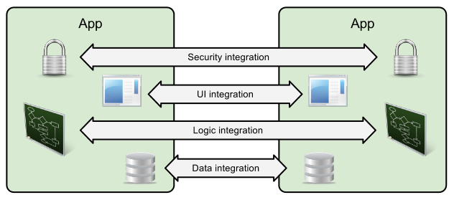
Image: Salesforce

Further, there are options regarding the depth of integration desired. Some options include:
- Full integration into a single management system
- Platform-based integration, with external services
- Custom integration with specialized bus
- Cloud-based integration with services and APIs
- Loose integration with services, APIs and middleware

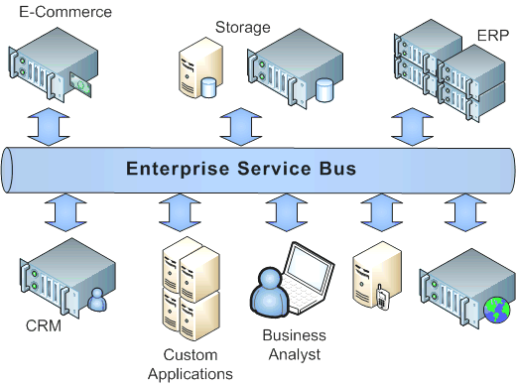
Image: Centeractive

GoC Platforms – what’s out there
The government of Canada supports numerous learning, information and resource systems. The list below is an incomplete listing of them:

- BuyAndSell - single source for government contracting, sales and services - https://buyandsell.gc.ca/

- GCCampus - the Canada School of Public Service online learning platform, front-ended with Drupal and incorporating Saba, Kaltura, and other back-end services - https://learn-apprendre.csps-efpc.gc.ca/

- GCPedia - Wikipedia-like repository of information and resources, accessible to members of the public service - http://www.gcpedia.gc.ca

- GCConnex - Elgg-based social networking service for members of the public service - https://gcconnex.gc.ca/splash/

- GCCollab - Newly launched Elgg-based social networkings service for members of the federal public service, provincial public service, and college and university members - https://gccollab.ca/newsfeed/

- National Science Library - as described in the ‘Virtual Libraries’ section above, a single interface to virtual libraries hosted by six of Canada’s science-based departments - http://fsl-bsf.scitech.gc.ca/eng/intranet/home/

- GoC webex - common conferencing system used by many government of Canada staff and departments - https://pwgsc-nh.webex.com

- Open government portal - access to data sets, dialogue on open government, and information requests - http://open.canada.ca/en

- Job Bank - www.jobbank.gc.ca

Integration Drivers
The integration of various services interfaces is driven by user needs, as mentioned above, but it is also driven by management and infrastructure needs.

The Canadian government’s Blueprint 2020 envisions a single integrated network of government services, defined as follows (Privy Council, 2015):

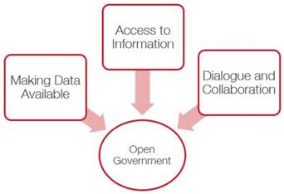
- An open and networked environment that engages citizens and partners for the public good, together with…
- A whole-of-government approach that enhances service delivery and value for money, enabled by…
- A modern workplace that makes smart use of new technologies to improve networking, access to data and customer service, and…
- A capable, confident and high-performing workforce that embraces new ways of working and mobilizing the diversity of talent to serve the country’s evolving needs.

Canada’s Draft Plan on Open Government (2016-2018) (GoC, 2016) initiative also envisions linking services and opening access to the public, as evidenced by the 2016-2018 roadmap:

- Enhance Access to Information
- Streamline Requests for Personal Information
- Expand and Improve Open Data
- Provide and Preserve Access to Information
- Define Approach for Measuring Open Government Performance
- Develop Open Government Skills across the Federal Public Service
- Embed Transparency Requirements in Federal Service Strategy
- Enhance Access to Culture and Heritage Collections

Employment and Occupations
Integration could also mean integration with additional Government of Canada services, specifications and standards related specifically to employment and occupations, especially within the Canadian public service.

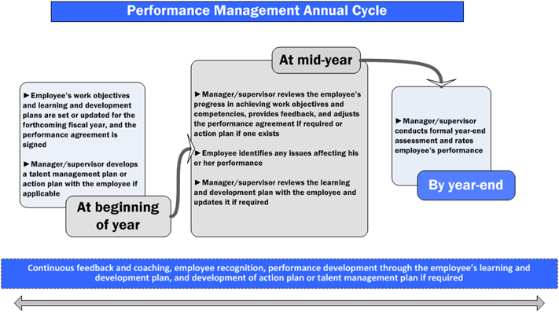
TBS, 2017

The National Occupational Classification system (NOC) is relevant to queries related to competencies and the associated occupations that may be related to the competencies. New versions are periodically released, which creates a need to updating integrated systems.

Other government also provide employment and training services and specifications. An example of this is the Ontario government’s Labour Market Information service at Advanced Education and Skills Development (AESD).

Statistics Canada contains numerous databases and information sources related to employment and labour in Canada. See StatsCan, 2016.

Finally, there are a number of third party employment and development services that could support and benefit from integration with CSPS, for example, Monster.com and LinkedIn.com.

The sector also includes a number of ‘match-making’ services:

- Ascensus - matching people to retirement plans (+ education)
- BetterUp - connects employees with professional coaches
- Changingedu - connecting teachers and students for after school tutoring
- Cofounders Lab - (also includes the former FounderDating)
- Handshake - matches students to jobs and internships
- Helpster - employers with people seeking blue-collar jobs
- Mitacs - builds partnerships between academia, industry, and the world
- Opportunity - networking and job finding
- RaiseMe - matches students to scholarships

Authentication and Single-Signon
For integration, one of the major drivers, and at the same time one of the greatest challenges, is authentication. The goal is to enable single sign-on - that is, a mechanism of logging in once and enjoying seamless access to the full suite of services.

Single sign-on systems must address numerous issues and challenges:
- Secure authentication, including two-factor authentication, certificate based authentication, biometrics, etc.
- Varied locations, and varied infrastructures, including personal computers and BYOD, and support for Virtual Public Networking (VPN)
- Authentication levels, groups or classes of security clearance (including time-sensitive granting and revoking of access)
- Secure environments, where authentication may be suspended or curtailed
- The extension of access to third party sites (such as virtual libraries, data repositories, learning management systems)

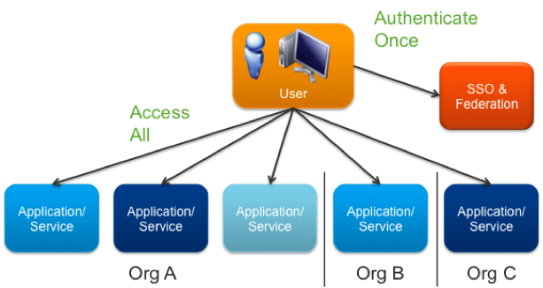
Image: VMWare

Training and development providers typically employ one or more of the following authentication services or schemes:

- Group Managed Service Accounts (gMSAs) - eg., University of Washington - “provide a higher security option for non-interactive applications/services/processes/tasks that run automatically but need a security credential.”

- Open Researcher and Contributor ID (ORCID) - used by publishers to track authors and contributors to scholarly publications

- Shibboleth - open source identity federation system, developed originally for colleges and universities, and is used to enable staff and students to work at cooperating institutions; currently employed by GCCampus

- EduRoam - worldwide academic login developed by the GÉANT network in Europe - it is especially useful to people visiting academic institution or attending conferences

- Trulioo - global identity service for APIs and applications

- Security Assertion Markup Language (SAML) - a set of specifications and implementations for signing users into sessions in applications.

- OpenID-like authentication - employing encrypted OAuth2-like mechanisms, such as Facebook, Twitter, and Google logins - OpenID provides a full list of implementors

A ‘trust framework’ is “is a general term to describe a set of auditable business, technical, and legal rules that apply to the identification, authentication, and authorization of accessing resources across organizations.” (DIACC, 2016) OIXNet maintains a registry of trust frameworks. In August, 2016, the Digital ID & Authentication Council of Canada (DIACC) released the Pan-Canadian Trust Framework (PCTF) Overview (DIACC, 2016a) to “incorporate Canadian principles, business interests, technical models and, demonstrate compliance with Canadian regulations. “

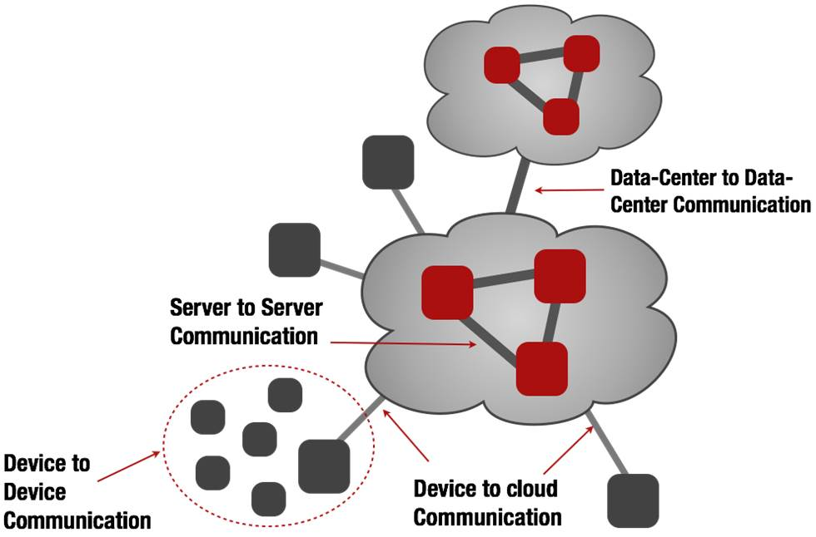
Distributed Platforms and Cloud Computing
The idea of a distributed platform is that from a service-level perspective it appears to be a single integrated system, but from a systems perspective it is running on a distributed architecture. (Image: DDS, 2014)

A good intuitive way to think of this is to imagine the web browser itself. From the user perspective, the web browser is the internet. But in fact the content and applications are delivered to the web browser from numerous third party servers.

ISO/IEC JTC 001/SC 38 "Cloud Computing and Distributed Platforms" manages standards related to:
- Service Oriented Architecture (SOA)
- Service Level Agreement
- Interoperability and Portability
- Data and their Flow Across Devices and Cloud Services
To date they have published 10 standards with four more under development. This creates a standard against with proposals for distributed services can be evaluated.

Cloud services and virtualization, once the domain of internet service providers and Linux enthusiasts, have matured and have now reached institutional, enterprise and even consumer-level adoption.

A full discussion of these services is beyond the scope of this paper, but it is likely that application integration providers and services will be required to be familiar with at least the following products and services:

o Environments: VMWare Fusion, VirtualBox
o Provisioners: Docker, Vagrant
o Providers: AWS, MS Server
o Services: MS Cognitive, Wolfram Alpha, Segment
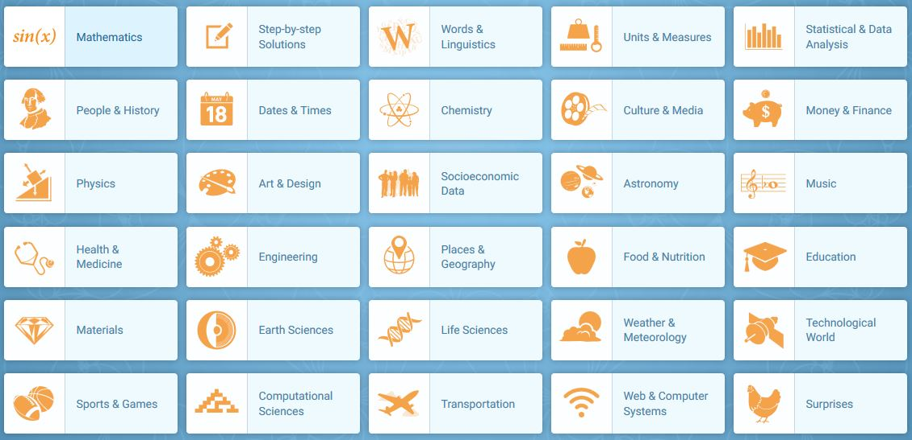
Wolfram Alpha

Some Applications
It is not anticipated necessarily that all services will employ all or any of services offered by, say, Wolfram Alpha or Amazon Web services. However it is important to note that it is very likely that over the next decade integration will mean that educational, development and training services will be expected to be offered as cloud services, and integrated into other platforms, including government of Canada platforms.

Sample applications of distributed computing environments could include the following:

- Distributed social networking - rather than rely on a single centralized platform, a distributed social networking environment supports the development of personal social networking and file sharing applications. Some examples include SoLID (being developed by Tim Berners-Lee), Keybase, and GNUSocial.

- Expert search - find people via their presence on various different social networks and environments, eg., identifying “the specific users who most influence others' activity and does so considerably better than simpler alternatives.” (Trusov, Bodapati & Mullen, 2010)

- Second screen - “a second screen based on multimedia package distribution compatible to different kinds of operating system, heterogeneous network and various Web browsers” (Lee, Yoo & Han, 2015)

- Distributed cloud-based simulation - for example, involving people from different branches of the military and security services in a single interactive scenario. (Eg. Fawkes, 2016).
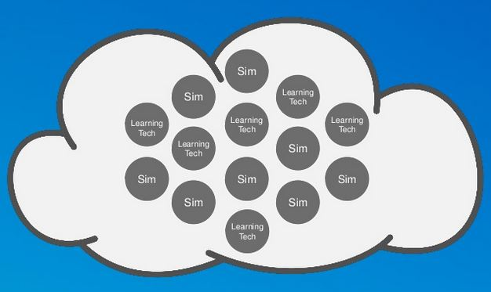

Existing Knowledge and Capabilities

Research Questions to be Posed

- What constitutes 'other platforms' for the purposes of this project?
- What does 'integration' mean?
- What knowledge of other platforms within GoC does CSPS have?
- Does CSPS environ and/or support linkages with employment and occupational platforms?
- How does CSPS support identification and single sign-on, and are these compatible with external systems?
- Could CSPS support changing the SSO mechanism with existing technology?
- Does CSPS have expertise and/or support for distributed environments, virtualized environments, and on- and off-campus provisioning?
- How would CSPS work with GCCollab? With public interactions?

Competency management implementation within the Canadian public service (Bonder, A., Bouchard, C., & Bellemare, G.: Competency-Based Management – An Integrated Approach to Human Resource Management in the Canadian Public Sector, Public Personnel Management, 40 (1) (2011)

N. G. Vinson, S. O'Donnell, I. Kondratova & H. Fournier. “Technological support of informal learning in the workplace”, Edmedia, 2015

